

**Department of Computing**

**Professional Software Projects**

**(55-508208-AF-20245)**

**Software Requirement Specification**

**Project:** Elanco

**Team ID:** Elanco 3

|  |  |
| --- | --- |
| **Name** | **ID** |
| **George Zablovskyy** | 34045427 |
| **Samuel Okunowo** | 33055721 |
| **Kenny Pham** | 33032878 |
| **Alex Hindmarsh** | 33077813 |
| **Michal Obrycki** | 33034146 |

Table of Contents

Introduction 3

Project Overview 3

Problem Statement 3

Project Objectives 4

System Requirements 5

Functional Requirements 5

Non Functional Requirements 6

User Roles 8

Personas 9

User Stories 12

System Architecture 26

C4 Context Diagram (level 1): 26

C4 Container Diagram (level 2): 27

Appendix: Tasks Completed 28

Appendix 2: GitHub Repository 30

References 30

# Introduction

As the Elanco 3 team, we were presented with a task to create a web-based project that would analyse images given by the user to then be categorised depending on their activities or behaviours based on the overall scenario of the image.

# 

# Project Overview

The project requires us to use pre-trained models and cloud-based APIs, such as Google Cloud’s Vertex AI, Google Cloud’s Vision AI, or Azure AI Vision. These models allow us to generate data from images of animals to determine their activity or behaviour, such as their emotional state or physical state. This project requires us to be creative and innovative, which allows us to demonstrate our ideas to the client.

# Problem Statement

The team was asked to explore cloud-based cognitive services to investigate how computer vision could automate the categorisation of animal activities and behaviour.

This technology could have applications in animal monitoring, product development, and customer experience. Elanco would like teams to develop a web-based prototype that can analyse images of animals and categorise their activities or behaviour based on clues in the images. The client is looking for various approaches for image analysis, focusing on using pre-trained models and cloud-based APIs, such as Google Cloud’s Vertex AI,

Google Cloud’s Vision AI or Azure AI Vision.

# Project Objectives

|  |
| --- |
| * **Produce test and training images of various animals' behaviours.** * **Research Cloud AI image recognition models' ability to recognise animals and their behaviours.** * **Test different AI models to see which is most effective for this task.** * **Fine-tune the chosen AI model to increase the accuracy of detection.** * **Create a web page to allow the user to interact with.** * **Create a connection to AI API to categorise activities or behaviours of animal images.** * **Create a database to store the data and mock up some data to imitate longer observation of the same animals.** * **Produce report pages to describe the gathered data visually.** * **Mock up the login page, user creation and users’ pet account set up.** * **Possibly create a Cloud email sending service to inform the user about the anomalies in detected data, e.g., a dog possibly sick.** |

# 

# System Requirements

## Functional Requirements

|  |  |  |  |
| --- | --- | --- | --- |
| **ID** | **Title** | **Description** | **Priority(MoSCoW)** |
| **FR01** | **Image Upload Functionality** | Users must be able to upload images of animals for analysis through the web-based prototype. | **Must Have** |
| **FR02** | **Integration with trained models** | The project must use one of trained models like Google Cloud Vision AI, Vertex AI, or Azure AI Vision for image analysis. | **Must Have** |
| **FR03** | **Animal activity/ behaviour categorisation** | The prototype must identify and categorise animal activities or behaviors based on the analysis of the images. | **Must Have** |
| **FR04** | **Report Generation** | The system must provide an output summary (e.g., categorised activity/behavior) in a readable format. | **Must Have** |
| **FR05** | **Multi Image Processing** | Allow users to upload and analyse multiple images simultaneously. | **Could Have** |
| **FR06** | **User Customisable Categories** | Allow users to define and add new categories for classification beyond predefined ones. | **Could Have** |
| **FR07** | **Live Video Processing** | Allow the user to use their in-built camera to process real-time animal behaviour. | **Could Have** |
| **FR08** | **Identify the location of a given image** | Outputs an idea of where the picture has been taken and gives its location. | **Could Have** |
| **FR09** | **Confidence Score** | Outputs a confidence score of how accurate the AI is from 0 to 1, as a traffic light colour. | **Should Have** |
| **FR10** | **Email notifications** | The system automatically sends emails to users whose animal behaviour has been | **Could have** |

## Non-Functional Requirements

|  |  |  |  |
| --- | --- | --- | --- |
| **ID** | **Theme** | **Description** | **MoSCoW** |
| **NFR01** | **Usability** | The system should be easy to use for the different types of users. | **Must Have** |
| **NFR02** | **Portability** | The system should be able to work on different devices, e.g. phones, tablets | **Must Have** |
| **NFR03** | **Security** | The system must ensure that user data is securely stored. | **Could Have** |
| **NFR04** | **Performance** | The system should process images and return results within 5 seconds | **Must Have** |
| **NFR05** | **Compatibility** | The system should be compatible with major web browsers (Chrome, Firefox, and Safari) | **Must Have** |
| **NFR06** | **Compatibility** | The system should be compatible when running on all mobile devices | **Could Have** |
| **NFR07** | **Scalability** | The system should be able to handle increased loads as more users join without performance degradation | **Could Have** |
| **NFR08** | **Error handling** | The system should output an appropriate error message depending on the user's input such as, wrong file format, connectivity issues etc. | **Must Have** |
| **NFR09** | **Security** | Images should be able to be uploaded securely, at least to meet basic privacy standards. | **Should Have** |

## 

# User Roles

|  |  |
| --- | --- |
| **Role** | **Description** |
| **Farmer User** | Farmers or livestock users who use the system to monitor and analise the behaviour of farm animals for better management and productivity.  **Responsibilities:**   * Upload and analise images of farm animals. * Categorise animal activities. * Receive alerts for unusual behaviour or health concerns. * Access historical behaviour trends for better farm management. * Generate reports on animal behaviour and activity trends. |
| **Pet Owner User** | Pet owners who use the system to track and understand their pet's behaviour and wellbeing.  **Responsibilities:**   * Upload and analyse images of their pets. * Receive categorised insights on pet activities. * Get alerts for unusual behaviour or potential health concerns. * Maintain a personal pet profile with behavioural history. * Share insights with vets for professional advice. * Receive recommendations for pet care based on behavioural patterns. |
| **Vet User** | Veterinarians who use the system to assess animal behaviour for diagnostic treatment purposes.  **Responsibilities:**   * Analyse images of farm animals or pets submitted by users. * Review categorised behaviours and detect possible health issues. * Access historical behavioural trends for diagnosis. * Provide recommendations or insights based on behavior patterns. * Generate reports for pet owners and farm users. * Integrate with medical records or other vet systems. |

# Personas

|  |  |
| --- | --- |
| **Shaun Wales** | |
| · Age: 41  · Occupation: Livestock Farmer  · Location: Doncaster, UK  · User Type: User  · Disability: None  · Quote: "Farming is not just a job; it's a way of life." | |
| **Background** | Shaun has been managing his family's livestock farm for over 20 years. He has a strong connection to the land and his animals. Shaun is familiar with traditional farming methods but is increasingly interested in technology that can enhance his farming practices. He often faces challenges related to animal health and behaviour but is eager to adopt solutions that improve efficiency. |
| **Goals** | • Easily monitor his livestock's health and behaviour more effectively  • Reduce feed wastage and ensure that all animals are eating and resting adequately.  • Document any health issues faced by his livestock promptly. |
| **Frustrations** | • Time consumption in manually tracking animal behaviour and health.  • Inefficient record keeping methods.  • Delays in receiving notifications about reserved media, forcing her to check manually and potentially miss out on items. |
| **Technology** | **Devices**: Laptop (Windows), smartphone (iPhone)  **Assistive Technology**: None |
| **Scenario** | One day, Shaun notices that some of his sheep are not behaving normally. He uses the app to take images of the sheep and upload them for analysis. The app provides insights into their behaviour, helping him identify potential health issues early and take necessary action. |

## 

|  |  |
| --- | --- |
| **Layla Mendes** | |
| · Age: 32  · Occupation: Veterinarian  · Location: Manchester, UK  · User Type: User  · Disability: None  · Quote: "The greatness of a nation and its moral progress can be judged by the way its animals are treated." - Mahatma Gandhi | |
| **Background** | Layla has been a veterinarian for 10 years, focusing on farm animals. She is dedicated to animal welfare and regularly visits farms to conduct health check-ups. Layla is well-versed in both traditional veterinary practices and modern technology. She believes that technology can significantly improve animal care. |
| **Goals** | • Providing more accurate diagnoses for her animal patients.  • Utilizing technology to gather data on animal behaviour and health, to make her assessments quicker and more reliable.  • Educating pet owners and farmers on best practices for animal care. |
| **Frustrations** | • Limitations of traditional diagnostic methods that rely heavily on physical examinations of animals.  • Challenges in communicating effectively with farmers and pet owners about animal health without concrete data. |
| **Technology** | **Devices**: Laptop (Windows), smartphone (iPhone)  **Assistive Technology**: None |
| **Scenario** | One day, Shaun notices that some of his sheep are not behaving normally. He uses the app to take images of the sheep and upload them for analysis. The app provides insights into their behaviour, helping him identify potential health issues early and take necessary action. |

## 

## 

## 

## 

# User Stories

|  |  |  |
| --- | --- | --- |
| **Title**: Upload Animal Picture | **Priority**: Must | **Estimate:** 5 points |
| As a user, I want to upload and scan a picture of an animal, which then gives me the type of animal, its current behaviour, and the level of accuracy of detection. | | |
| **Acceptance Criteria**  **Given** that I am on the upload page,  **When** I upload a picture of an animal,  **Then** the system should:  · Display what type of animal is in the picture  . Display the behaviour of the animal that is currently being shown  . Display the accuracy of detection in the form of a traffic light colour where,  Red is below 50%, Orange below 65%, and green above 65%  . Uploaded images are stored in the Uploads folder  . Draw a boxing around each animal and label them accordingly  · Allow me to upload another image | | |

|  |  |  |
| --- | --- | --- |
| **Title**: Upload Multiple Images | **Priority**: Could | **Estimate:** 5 points |
| As a user, I want to upload multiple images simultaneously and receive different results for each one | | |
| **Acceptance Criteria**  **Given** I am on the upload page,  **When** I upload multiple pictures of a animal/animals,  **Then** the system should:  · Query the AI in order to deduce the type of animal and the behaviour that is being shown  · Display what types of animals are in the picture  . Display the behaviours of the animals that are currently being shown  . The data should be stored in database  · Allow me upload another image/ set of images | | |

|  |  |  |
| --- | --- | --- |
| **Title**: View Analysis History | **Priority**: Must have | **Estimate:** 5 points |
| As a user, I want to view my previous uploaded images so I can see if there are any patterns on my animals behaviours | | |
| **Acceptance Criteria**  **Given** I am on the home page,  **When** I press the view history button,  **Then** the system should:  · Display a list of all previous uploaded scans  · Display what behaviour was shown in all those previous scans  . Allow me to delete all previous history or just one image off the history  · Allow me upload another image/ set of images | | |

|  |  |  |
| --- | --- | --- |
| **Title**: Live Video Processing | **Priority**: Could | **Estimate:** 15 points |
| As a user, I want to be able to use my in-built camera/CCTV to detect animal behaviour in real time. | | |
| **Acceptance Criteria**  **Given** I am on the upload page,  **When** I’m uploading a live video of my animal/animals,  **Then** the system should:  · Query the AI in order to deduce the type of animal and the behaviour that is being shown  · Display what types of animals are in the picture  . Display the behaviours of the animals that are currently being shown | | |

# 

|  |  |  |
| --- | --- | --- |
| **Title**: Upload Multiple Images | **Priority**: Should | **Estimate:** 5 points |
| As a user, I want to upload multiple images simultaneously and receive different results for each one | | |
| **Acceptance Criteria**  **Given** I am on the upload page,  **When** I upload multiple pictures of a animal/animals,  **Then** the system should:  · Query the AI in order to deduce the type of animal and the behaviour that is being shown  · Display what types of animals are in the picture  . Display the behaviours of the animals that are currently being shown  · Allow me upload another image/ set of images | | |

# 

|  |  |  |
| --- | --- | --- |
| **Title**: Detect Goat Grazing | **Priority**: Could | **Estimate:** 5 points |
| As a farmer, I want to detect when my goats are grazing so that I can ensure they are getting enough food. | | |
| **Acceptance Criteria**  **Given** I am on the upload page,  **When** I upload multiple pictures of my goats,  **Then** the system should:  · Confirm that the goats are grazing  · Provide insights on their feeding patterns  . Allow me to monitor their grazing status continuously | | |

# 

|  |  |  |
| --- | --- | --- |
| **Title**: Monitor Chicken Movement | **Priority**: Could | **Estimate:** 5 points |
| As a farmer, I want to monitor the movement patterns of my chickens so that I can identify if they are running or walking and ensure they are healthy and active. | | |
| **Acceptance Criteria**  **Given** I am on the upload page,  **When** I upload multiple pictures of my chickens,  **Then** the system should:  · Distinguish between running and walking behaviours  · Provide alerts for unusual activity levels  . Allow me to view movement data history | | |

# 

|  |  |  |
| --- | --- | --- |
| **Title**: Track Young Chick Behaviour | **Priority**: Could | **Estimate:** 5 points |
| As a farmer, I want to track the behavior of young chicks so that I can quickly notice any signs of distress or illness. | | |
| **Acceptance Criteria**  **Given** I am on the upload page,  **When** I upload multiple pictures of my chicks,  **Then** the system should:  · Identify signs of distress or illness  · Provide recommendations for care if issues are detected  . Allow me to log observations for future reference | | |

|  |  |  |
| --- | --- | --- |
| **Title**: Thermal Imaging | **Priority:** Should | **Estimate:** 10 points |
| As a pet owner, I want to be able to detect my pets' temperature to keep track of their state to ensure that they are healthy and well throughout the day. | | |
| **Acceptance Criteria**  **Given** I am on the upload page,  **When** I upload a live feed of my pet using a thermal camera,  **Then** the system should:  · Identify the temperature of the pet  · Record the temperature on a graph  . Allow me to access the graph for trends/ patterns that can be used to diagnose the state of my pet | | |

|  |  |  |
| --- | --- | --- |
| **Title**: Upload Animal Picture Containing Multiple Animals | **Priority**: Should | **Estimate:** 5 points |
| As a user, I want to upload and scan a picture of many animals at once which then gives me the types of animals and their current behaviour. | | |
| **Acceptance Criteria**  **Given** I am on the upload page,  **When** I upload a picture of multiple animal,  **Then** the system should:  · Display what types of animals are in the picture  . Display the behaviours of the all the animals that are currently being shown  · Allow me to upload another image | | |

# 

|  |  |  |
| --- | --- | --- |
| **Title**: Create report for all animals detected | **Priority**: Must have | **Estimate: 1**5 points |
| As a user, I want to be able to create various reports on all animals’ behaviours detected and stored in the database. | | |
| **Acceptance Criteria**  **Given** that I am logged in  **When** I go to the ‘All animals report’ page  **Then** the system should:  · Allow me to choose the timeframe for the report  · Allow me to choose all animals or a particular group: Cats or Dogs.  · Allow me to choose various report options, e.g., average sleep time, sleeping patterns, feeding patterns, healthy to unhealthy ratio, number of reported anomalies, and so on. (still to be decided on).  . Reports shall vary in type accordingly to the presented data to maximise the readability | | |

|  |  |  |
| --- | --- | --- |
| **Title**: Access User Profile | **Priority**: Should | **Estimate:** 5 points |
| As a user, I want to be able to create a user profile that I can log into that retains my information | | |
| **Acceptance Criteria**  **Given** I am on the main home page,  **When** I press the login button / profile button,  **Then** the system should:  · Allow me to access my user profile  · Display my name along with the main page  . Display new features that come with having an account like seeing the history button to view previous animal scans and any additional pieces of information such as graphs, pie charts etc. of my data. | | |

|  |  |  |
| --- | --- | --- |
| **Title**: Create user’s animal profile | **Priority**: Must | **Estimate:** 15 points |
| As a user, I want to create a profile for my animals so that I can track and store specific details about them (e.g., name, age, breed, picture, health conditions). | | |
| **Acceptance Criteria**  **Given** I am on the ‘Create animal profile’ page  **When** I input my animal’s details (e.g. name, age, breed, health conditions, picture),  **Then** the system should:  · Validate all fields and store the entered information.  · Display a list of all created animal profiles under my account.  . Allow me to update or delete an animal profile. | | |

## 

|  |  |  |
| --- | --- | --- |
| **Title**: Create report of particular animal | **Priority**: Should | **Estimate: 5 points** |
| As a user, I want to be able to view a report of one of my animal’s behavior over a period of time so I can quickly check its activity and how it is doing | | |
| **Acceptance Criteria**  **Given** that I am on the profile page of an animal  **When** I click on create report and enter a time period  **Then** the system should:  . Display what behaviors are more common at which times  e.g. sleeping is most common at 9pm  . any worrying behavior  excessive itching, foaming etc.  . display the timescale for positive/essential behavior and display if it has been too long without one  E.g. too long without eating, drinking, playing, socialising, sleeping | | |

# System Architecture

## 

## C4 Context Diagram (level 1):

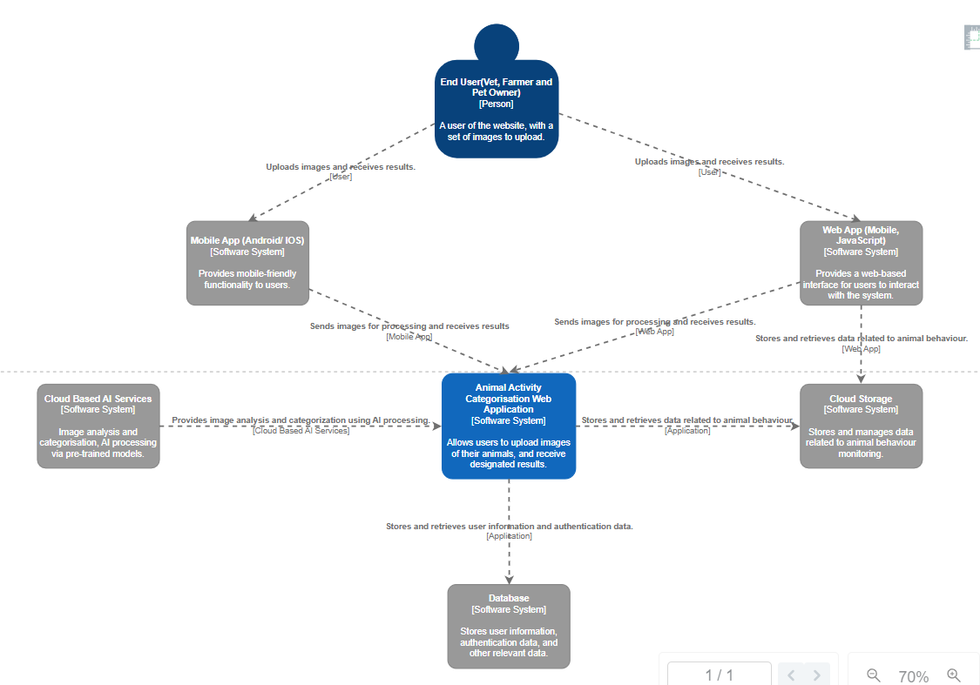

## C4 Container Diagram (level 2):

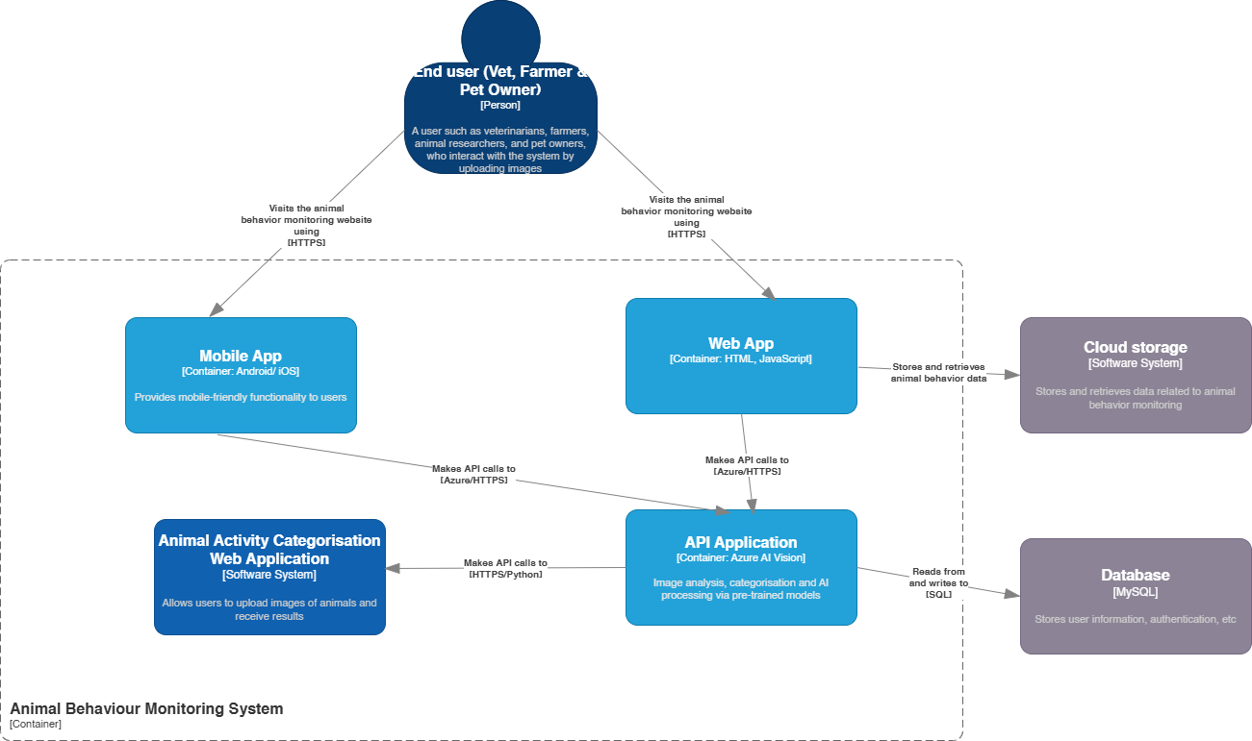

# Appendix: Tasks Completed

|  |  |
| --- | --- |
| **Name:** | **Tasks Completed:** |
| **Michael Obrycki** | - Prepare initial questions to Elanco  - Prepare for the Product Owner role  - Build Python/Flask prototype for testing  - Train AWS Rekognition AI  - Test OpenAI  - Test Google Vertex AI  - Work with the rest of the team on documentation |
| **Kenny Pham** | - Tested Azure AI  - Trained Azure AI on various animal behaviours  - Integrated Azure AI into a website which now allows us to test the AI more simply  - Integrated Computer Vision AI (different part of azure ai but it’s a pre-trained model) into the website which now gives us descriptions and helps as a backup for animals that we haven’t trained.  - Added multi-animal functionality by using boxes to isolate animals in pictures  - Worked with the rest of the team on documentation  - Helped the team with learning Azure and how to set up the code on the others systems |
| **Alex Hindmarsh** | - |
| **Samuel Okunowo** | * Created the GitHub repository for the project and added team members as collaborators. * Learned and implemented scrum role and principles * Trained AI models on different behaviours. * Tested and evaluated Azure Custom Vision for its effectiveness in image classification and behaviour detection, with tags. * Worked on learning Flask and Python to contribute to backend development. * Developed the database schema to be used for storing user information, animal profiles, and behaviour analysis results. * Worked with the rest of the team on gathering requirements and documentation (user personas, user stories, non-functional requirements, container diagram). |
| **George Zablovskyy** | * Worked on the documentation (User Stories, User Roles, Functional Requirements, C4 Context Diagram, Introduction of the Document such as Project Overview and Objectives). * Learned the role of Technical Lead and implemented my principles across the team. * Tested a local Python machine AI model. * Trained my Python local model on different animals and behaviours. * Implemented a module in Python to allow for multiple animal recognition. * Contributed a little to the prototype website by working on the frontend of the website. |

# Appendix 2: GitHub Repository

Table - GitHub repositories

|  |  |
| --- | --- |
| **Student name** | **GitHub repositories** |
| George Zablovskyy | <https://github.com/GeorgeZablovskyy/psp-work-diary> |
| Samuel Okunowo | <https://github.com/Sammiejohnsonnl/elanco3-work-diary> |
| Michal Obrycki | Individual: <https://github.com/bambambku/Elanco3_private>   Branch in group repo: <https://github.com/Sammiejohnsonnl/Elanco3/tree/michael> |
| Kenny Pham | <https://github.com/DDKPhamm/Elanco3/> |

# References

TONYE, G. (2021, September 4). *Machine Learning Confidence Scores — All You Need to Know as a Conversation Designer*. Voice Tech Global. https://medium.com/voice-tech-global/machine-learning-confidence-scores-all-you-need-to-know-as-a-conversation-designer-8babd39caae7